Day 4 tasks:

Session 1:

Created the resume portfolio using Bootstrap.

Deployed the portfolio on Render (Deployment tool).

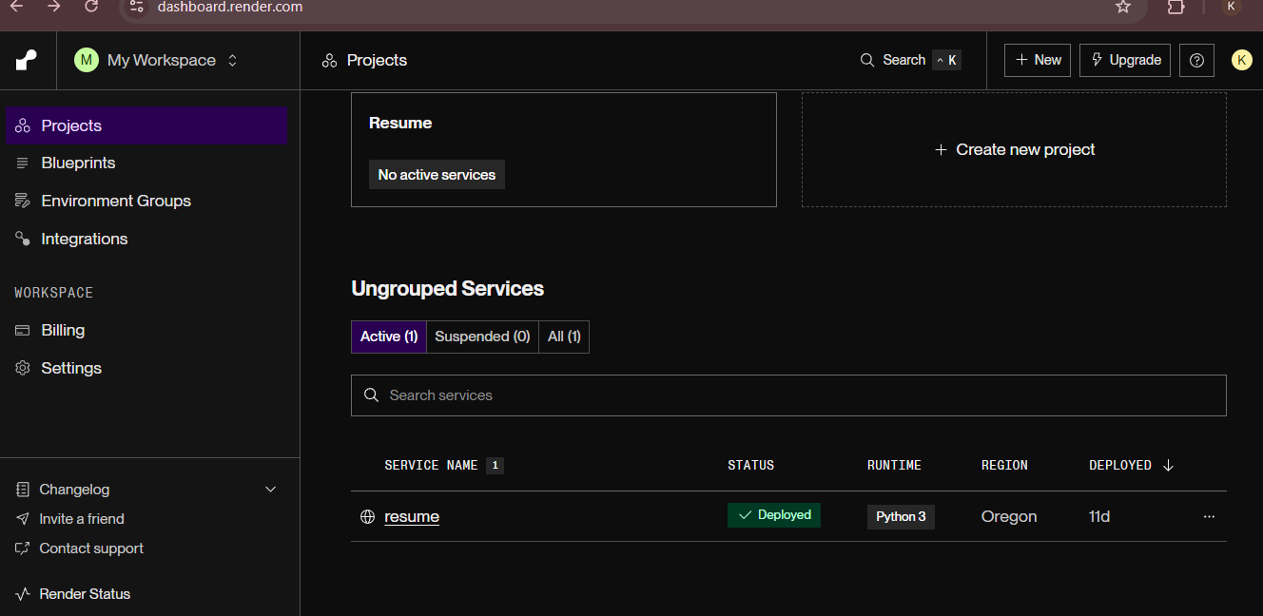

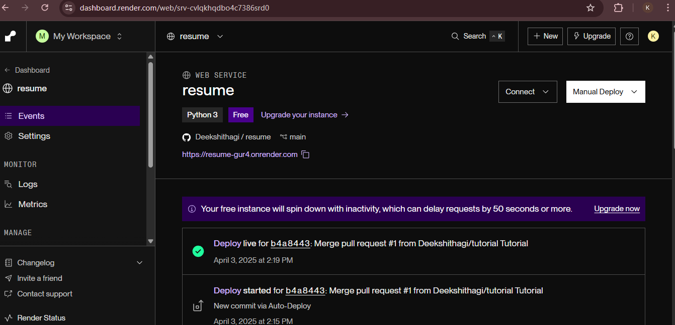

Session 2:

1. Installing FinTest Pro Extension

Added test.py to the portfolio website folder.

2)Setting Up GitHub Actions for CI/CD

3)Managing Dependencies

Added FastAPI and pytest dependencies to requirements.txt for seamless

integration and testing.

